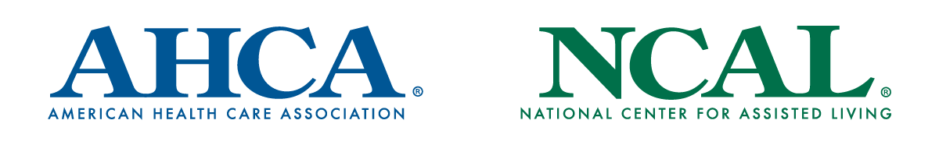

#GetVaccinated Campaign: Social Media Toolkit

Thank you for supporting the effort to get long term care staff and residents vaccinated for COVID-19. Below are template social media posts for you to use via your own social channels, as well as best practices and recommendations for posting.

Best Practices
- Use our campaign hashtag #GetVaccinated to keep the conversation consistent and searchable on social.
- Feel free to tag @ahcancal and other partner organizations as you see fit.
- Actively respond to tweets/comments to stir up discussion.
- Use video and photos of staff or residents receiving the vaccine (done safely and with their permission). Multimedia increases social media engagement and will reinforce our message.

Sample Posts
Please feel free to utilize the below examples in their entirety or adjust as appropriate to fit specific needs; they are flexible for use across Facebook, Instagram, LinkedIn and Twitter.
Post 1
We are working hard to protect our residents and staff as we continue to fight this pandemic – and soon, we’ll take a huge step forward: http://ahcancal.org/getvaccinated @ahcancal #GetVaccinated

Post 2
Our residents and staff agree: #GetVaccinated. Let’s continue the fight together. http://ahcancal.org/getvaccinated @ahcancal
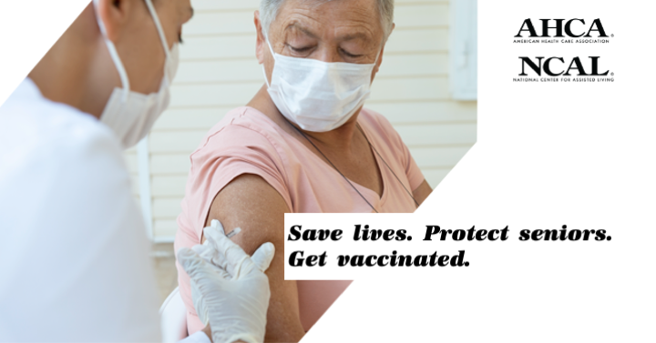
Post 3
We join @ahcancal and long term care providers around the country to support the effort to #GetVaccinated for the safety of our residents, staff and communities. http://ahcancal.org/getvaccinated

